SYSTEM REQUIREMENTS – 22070006060_Can HaktanUnat

1. **Case Study**

**A second-hand car sales system will be developed for web and mobile platforms. The primary purpose of this secondhand car sales system to be developed is to store and manage detailed information about the customer, car models, sales advertisements, and car owners. Car owners logging into the system with their name, surname, e-mail address, and password will be able to enter a new car advertisement on the system, view, edit, delete, and remove their existing advertisements. The owner of the car will enter and save the details of the announcement of the sales, such as the type of car, year of manufacture, brand, model, fuel type, engine, transmission, mileage, sales price, and car pictures. In addition, the car owner can add equipment such as fog lights, foldable mirrors, parking sensors, central locking, and a glass roof to their car. When the car owner adds a new listing or makes any changes to the listing, system administrators' approval will be required for the listing to be published. After the system administrators approve the announcement, the announcement will be published. Published ads will be displayed as shop window ads by customers who want to buy a car. Customers can examine the details of the cars they want to buy on the window advertisements. In addition, customers will be able to search for ads in detail by using information such as the type of car they want to buy, the year of manufacture, brand, model, fuel type, engine, transmission, mileage, and sales price. Through the system to be developed, customers can compare the car advertisements they are interested in. In addition, customers will be able to access the contact information of the car owners regarding the cars they are interested in, make comments, and express their opinions through the system. Apart from the transactions that car owners and customers can perform on the system, system administrators can enter and update information such as new car type, brand, model, and car hardware through the system management panel. The system, which will work on all web and mobile browsers, will support 5 million users simultaneously. Data belonging to customers and car owners will be secured using the MD5 encryption algorithm through the system with a strong database infrastructure. In the secondhand car sales system to be developed, advanced search algorithms will be used to ensure that the response time for any query will be less than 2 seconds. In addition, the system to be developed will be 100% secure against unauthorized user logins. The time that the car sales system to be developed will be closed due to routine maintenance will be at most 30 minutes in a one-month operating period.**

## **Requirements**

## **Use case Diagram**

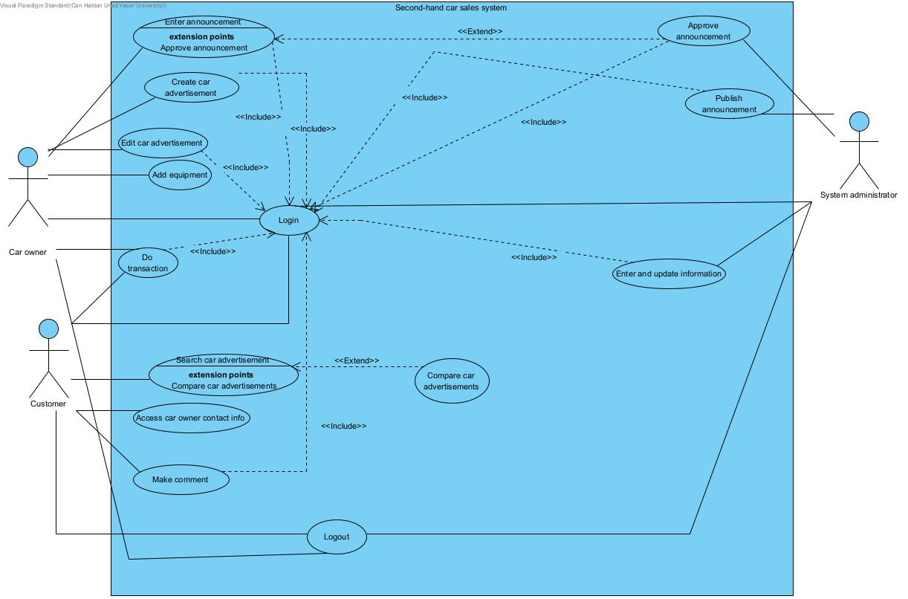

Note: I changed my use case diagram.

## **Use case Specification**

|  |  |  |
| --- | --- | --- |
| Use Case UC-1 | **Login** | |
| Trigger(s) | **The user (car owner, customer, or system administrator) wants to login to system.** | |
| Actor(s) | **Car Owner**  **Customer**  **System Administrator** | |
| Preconditions: | **Car Owner, Customer, and System Administrator are not logged in.**  **Accounts for customers, system administrators, and car owners are created.** | |
| Postconditions: | **Car Owner, Customer, or System Administrator logins to the system.** | |
| Flow of Events for Main Success Scenario: | | | |
| **->** | **1.** | **The user goes to system.** |
| **<-** | **2.** | **The system prompts asks to fill username, email, and password information.** |
| **->** | **3.** | **The user enters the necessary login information.** |
| **<-** | **4.** | **The system verifies the given information.** |
|  | **5.** | **The user (car owner, customer, system administrator) logins to the system.** |
| Flow of Events for Extensions (Alternate Scenarios): | | | |
| **<-** | **1.** | **Invalid Login Information(3A1): The system detects that the entered information is invalid.** |
|  | **2.** | **3A2. User did not enter any information** |
|  |  |  |

|  |  |  |
| --- | --- | --- |
| Use Case UC-2 | **Create car advertisement** | |
| Trigger(s) | **Car owner wants to advertise his car into the system.** | |
| Actor(s) | **Car Owner** | |
| Preconditions: | **Car Owner is logged in to system.** | |
| Postconditions: | **Car advertisement is successfully created.** | |
| Flow of Events for Main Success Scenario: | | | |
| **->** | **1.** | **Car owner clicks to “create new car advertisement” button.** |
| **<-** | **2.** | **System displays the necessary information to the screen.** |
| **->** | **3.** | **Car owner enters the required information about their car.** |
| **<-** | **4.** | **Car owner fills out all the necessary information that is required.** |
| **->** | **5.** | **Car owner saves the car advertisement..** |
| **<-** | **6.** | **Car owner successfully creates a car advertisement.** |
| Flow of Events for Extensions (Alternate Scenarios): | | | |
| **<-** | **1.** | **Incomplete Information(4A1)**:**Car owner enters incomplete or invalid information.** |
|  | **2.** | **5A1. Car owner forgets to save the car advertisement.** |

|  |  |  |
| --- | --- | --- |
| Use Case UC-3 | **Edit car advertisement** | |
| Trigger(s) | **Car owner wants to edit or change something about the car advertisement.** | |
| Actor(s) | **Car Owner** | |
| Preconditions: | **Car Owner is logged in and has already existed car advertisement.** | |
| Postconditions: | **The car advertisement is successfully updated by car owner.** | |
| Flow of Events for Main Success Scenario: | | | |
| **->** | **1.** | **Car Owner goes to existed car advertisement.** |
| **<-** | **2.** | **The system presents the necessary screen for editing a car advertisement.** |
| **->** | **3.** | **Car Owner edits the selected advertisement.** |
| **<-** | **4.** | **The additional changes are saved to the car advertisement.** |
|  | **5.** | **The car advertisement is successfully updated.** |
| Flow of Events for Extensions (Alternate Scenarios): | | | |
|  | **1.** | **Incomplete Information (3A1): The car owner enters incomplete or invalid information** |
| **<-** | **2.** | **System Error(4A1): system error or technical issue during the save process** |

|  |  |  |
| --- | --- | --- |
| Use Case UC-4 | **Search car advertisement** | |
| Trigger(s) | **Customer wants to see some car advertisements on the system.** | |
| Actor(s) | **Customer** | |
| Preconditions: | **Customer is on the system page.** | |
| Postconditions: | **Customer successfully viewing the searched car advertisements.** | |
| Flow of Events for Main Success Scenario: | | | |
|  | **1.** | **Customer goes to car advertisement search engine.** |
|  | **2.** | **Customer enters specific information about the car they want to search.** |
|  | **3.** | **Customer views the displayed car advertisements.** |
| **->** | **4.** | **The system displays all the related car advertisements that match with the given information.** |
| **<-** | **5.** | **Customer successfully searched the car advertisements.** |
| Flow of Events for Extensions (Alternate Scenarios): | | | |
|  | **1.** | **Search Error(1A1): The system displays an error message.** |
|  | **2.** | **No Matching Advertisements(3A1): There are no car advertisements that match the customer's search criteria** |

|  |  |  |
| --- | --- | --- |
| Use Case UC-5 | **Access car owner contact info** | |
| Trigger(s) | **Customer wants to contact to car owner.** | |
| Actor(s) | **Customer** | |
| Preconditions: | **Customer is logged in and customer is at the car owner’s car advertisement.** | |
| Postconditions: | **Customer access car owner’s contact information successfully.** | |
| Flow of Events for Main Success Scenario: | | | |
| **->** | **1.** | **Customer finds the car owners car advertisement.** |
| **<-** | **2.** | **Customer looks for car owner’s contact information in car owners car advertisement.** |
| **->** | **3.** | **Customer finds the car owner’s contact information.** |
|  | **4.** | **Customer accesses car owner’s contact information.** |
| Flow of Events for Extensions (Alternate Scenarios): | | | |
| **<-** | **1.** | **No Contact Information Provided(3A1): Car owner has not provided contact information in the advertisement.** |
|  | **2.** | **No Contact Information Provided (4A1): The system informs the customer that contact information is not available.** |

|  |  |  |
| --- | --- | --- |
| Use Case UC-6 | **Make comment** | |
| Trigger(s) | **Customer wants to give feedback about the system or car advertisement.** | |
| Actor(s) | **Customer** | |
| Preconditions: | **Customer is logged in and customer is at the system page.** | |
| Postconditions: | **Customer successfully posts the comment on system.** | |
| Flow of Events for Main Success Scenario: | | | |
| **->** | **1.** | **Customer finds the car advertisement page.** |
| **<-** | **2.** | **Customer types their comment message.** |
| **->** | **3.** | **Customer saves their comment.** |
| **<-** | **4.** | **Customer publishes the comment.** |
| Flow of Events for Extensions (Alternate Scenarios): | | | |
| **<-** | **1.** | **CommentValidationErrors(4A1): Thecommentcontainsinvalidcharacters, exceedscharacterlimits, orothervalidationissues.** |

|  |  |  |
| --- | --- | --- |
| Use Case UC-7 | **Enter announcement** | |
| Trigger(s) | **Car owner wants to announce something in the system.** | |
| Actor(s) | **Car owner** | |
| Preconditions: | **Car owner is logged in.** | |
| Postconditions: | **Car owner completes the entering announcement process.** | |
| Flow of Events for Main Success Scenario: | | | |
| **->** | **1.** | **Car owner goes to system page and selects enter an announcement.** |
| **<-** | **2.** | **Car owner enters the new changes to the announcement.** |
| **->** | **3.** | **Car owner submits the announcement.** |
| **<-** | **4.** | **Car owner successfully finishes the process of entering the announcement.** |
| Flow of Events for Extensions (Alternate Scenarios): | | | |
| **<-** | **1.** | **Validation Errors(2A1): Car owner enters invalid changes to the announcement.** |

|  |  |  |
| --- | --- | --- |
| Use Case UC-8 | **Approve announcement** | |
| Trigger(s) | **Car owner wants to see their entered announcement to be published in the system.** | |
| Actor(s) | **System Administrator** | |
| Preconditions: | **System administrator is logged in to the system and car owner has finished entering their announcement on the system.** | |
| Postconditions: | **Announcement is approved by the system administrator.** | |
| Flow of Events for Main Success Scenario: | | | |
| **->** | **1.** | **System administrator sees the submitted announcement from car owner.** |
| **<-** | **2.** | **System administrator reviews the announcement details.** |
| **->** | **3.** | **System administrator checks the announcement to make sure it meets the necessary conditions to be approved announcement.** |
| **<-** | **4.** | **System administrator approves the car owner’s announcement.** |
| Flow of Events for Extensions (Alternate Scenarios): | | | |
| **<-** | **1.** | **Disapproval(3A1): The system administrator determines that the announcement does not meet approval criteria.** |

|  |  |  |
| --- | --- | --- |
| Use Case UC-9 | **Publish announcement** | |
| Trigger(s) | **System administrator wants to publish Car owner’s approved announcement .** | |
| Actor(s) | **System Administrator** | |
| Preconditions: | **System administrator is logged in to the system and car owner’s announcement was approved by the system administrator.** | |
| Postconditions: | **Car owner’s announcement is published by the system administrator.** | |
| Flow of Events for Main Success Scenario: | | | |
| **->** | **1.** | **System administrator goes to approved announcements lists.** |
| **<-** | **2.** | **System administrator selects the approved announcement that they wish to publish.** |
| **->** | **3.** | **System displays a message for publishing announcement confirmation.** |
| **<-** | **4.** | **System administrator selects confirm publish button.** |
|  | **5.** | **System prompts a message that announcement is successfully published.** |
| Flow of Events for Extensions (Alternate Scenarios): | | | |
| **<-** | **1.** | **Errors and Bugs(5A1): System errors and bugs which causes not any prompt message that says announcement was successful.** |

|  |  |  |
| --- | --- | --- |
| Use Case UC-10 | **Enter and update information** | |
| Trigger(s) | **System administrator decides to enter or update information through the system management panel.** | |
| Actor(s) | **System administrator** | |
| Preconditions: | **System administrator is logged in to the system.** | |
| Postconditions: | **System administrator successfully updates information through the system management panel.** | |
| Flow of Events for Main Success Scenario: | | | |
| **->** | **1.** | **System administrator goes to system management panel.** |
| **<-** | **2.** | **System administrator enters the new information (new car type , brand, model, hardware).** |
| **->** | **3.** | **Information is updated through the system management panel.** |
| Flow of Events for Extensions (Alternate Scenarios): | | | |
| **<-** | **1.** | **Validation Errors(2A1): entered information contains errors, is incomplete** |

|  |  |  |
| --- | --- | --- |
| Use Case UC-11 | **Do transaction** | |
| Trigger(s) | **Customer wants to do money transaction because customer wants to buy the car owner’s car.** | |
| Actor(s) | **Car owner**  **Customer** | |
| Preconditions: | **Customer and car owner are logged in.**  **Car owner has entered the bank account information into system.** | |
| Postconditions: | **Car owner receives the money from transaction.**  **Customer bought the car owner’s car.**  **Car owner sold their car.**  **Customer becomes the owner of the car.** | |
| Flow of Events for Main Success Scenario: | | | |
| **->** | **1.** | **Customer uses car owner’s contact information to expresses the intention to buy the car from the car owner.** |
| **<-** | **2.** | **Car owner and customer negotiate the transaction and price of the car.** |
| **->** | **3.** | **Customer and car owner reaches an agreement on the final price.** |
| **<-** | **4.** | **Customer sends the money to car owner’s entered bank account via system.** |
|  | **5.** | **The car owner verifies the money in their bank account.** |
|  | **6.** | **System updates the car advertisement as a “SOLD” status.** |
|  | **7.** | **Customer receives the car that they bought.** |
|  | **8.** | **The system updates ownership details, transferring the car to the customer.** |
|  | **9.** | **Transaction is successfully done between customer and car owner.** |
| Flow of Events for Extensions (Alternate Scenarios): | | | |
| **<-** | **1.** | **Failed Transaction(9A1): the transaction fails** |

|  |  |  |
| --- | --- | --- |
| Use Case UC-12 | **Add equipment** | |
| Trigger(s) | **Car owner wants to add some additional car equipment to their car.** | |
| Actor(s) | **Car owner** | |
| Preconditions: | **Car owner has a car.** | |
| Postconditions: | **Additional car equipment is successfully added to car owner’s car.**  **If car owner has a car advertisement which has additional car equipment, car owner is required to system administrators' approval.** | |
| Flow of Events for Main Success Scenario: | | | |
| **->** | **1.** | **Car owner visits a car shop that sells car equipments.** |
| **<-** | **2.** | **Car owner finds the equipment they want to add to their car.** |
| **->** | **3.** | **Car owner pays the price of the equipment.** |
| **<-** | **4.** | **Car owner successfully adds the selected equipment to their car.** |
| Flow of Events for Extensions (Alternate Scenarios): | | | |
| **<-** | **1.** | **Equipment Compatibility Check(2A1): The equipment purchased is not compatible with the car** |

|  |  |  |
| --- | --- | --- |
| Use Case UC-13 | **Compare car advertisements** | |
| Trigger(s) | **Customer wants to compare different car advertisements between each other.** | |
| Actor(s) | **Customer** | |
| Preconditions: | **Customer is logged in to system.** | |
| Postconditions: | **Customer is now able to compare different car advertisements between each other.** | |
| Flow of Events for Main Success Scenario: | | | |
| **->** | **1.** | **Customer goes to the search section for car advertisements within the system.** |
| **<-** | **2.** | **Customer enters the car information they want to see in the shop window.** |
| **->** | **3.** | **System displays the car advertisements based on given information.** |
| **<-** | **4.** | **Customer searches a different car advertisement other than the initial car advertisement.** |
|  | **5.** | **Customer successfully compares the car advertisements between each other.** |
| Flow of Events for Extensions (Alternate Scenarios): | | | |
| **<-** | **1.** | **Search Error (1A1): There is an error in the search process.** |
|  | **2.** | **No Matching Advertisements(3A1): There are no car advertisements that match the customer's search criteria** |
|  | **3.** | **Search Error (4A1): There is an error in the search process.** |

|  |  |  |
| --- | --- | --- |
| Use Case UC-14 | **Logout** | |
| Trigger(s) | **The user (car owner, customer, or system administrator) wants to logout of the system.** | |
| Actor(s) | **Car owner**  **Customer**  **System administrator** | |
| Preconditions: | **Car Owner, Customer, or System Administrator are logged in.** | |
| Postconditions: | **Successful logout for Car Owner, Customer or System Administrator.** | |
| Flow of Events for Main Success Scenario: | | | |
| **->** | **1.** | **User requests the logout action.** |
| **<-** | **2.** | **System recognizes the logout request and starts the logout process for the user.** |
| **->** | **3.** | **The system terminatesthe user logout request.** |
| **<-** | **4.** | **The system displays a confirmation message that shows to user that successful logout.** |
| Flow of Events for Extensions (Alternate Scenarios): | | | |
| **<-** | **1.** | **Logout Error(3A1): There is an error during the logout process** |